Here are the list of name, logos of media publication house, link to their publication, a short tile of the article and a screenshot of each publication of Project Zul by Kaavya
> In the Home page, ‘As Featured On’ section, only the logos will come, like this 👇🏻, each logo when clicked on will open the article on a separate window. Kaavya’s logos will come in the second line, select from what is listed in this document, the ones with the link.
Please ensure in the top row, the logos related to Aarav’s articles open the correct articles, please take help from Svea on this.
Note: please note that the below image is missing Kaavya’s main article ET Edge logo, so do not blindly follow the list in existing website, follow this document
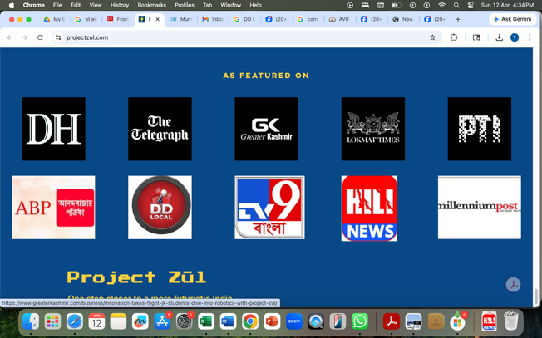
> In Media Page, for each article, make one media card. Inside each card, place:
- The Publication Name at the top
Publication logo top-left
- Article screenshot as the main visual
- Headline or short title below it
- A small link like “Read article” (for the print articles with no link, this will not be there)
- Make either the entire card clickable or the link
Please also arrange Aarav’s article also in the above format in the media page, take help from Svea to compile his articles.
Kaavyas ET Edge (first article in below list) should be highlighted, so make this card bigger and sit alone taking the entire width of the screen. Other cards can come below it 2/3 in a row.
Do the same for Aarav, select one of his main article to highlight.
1)Publication Name: ET Edge
Publication Logo

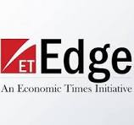
Short Title: From Classroom to Capability: How Kaavya Majumder’s Project Zūl – West Bengal chapter reflects the future of India’s STEM talent pipeline
Link
https://etedge-insights.com/in-focus/trending/from-classroom-to-capability-how-kaavya-majumders-project-zul-west-bengal-chapter-reflects-the-future-of-indias-stem-talent-pipeline/
Screenshots – use the one which fits
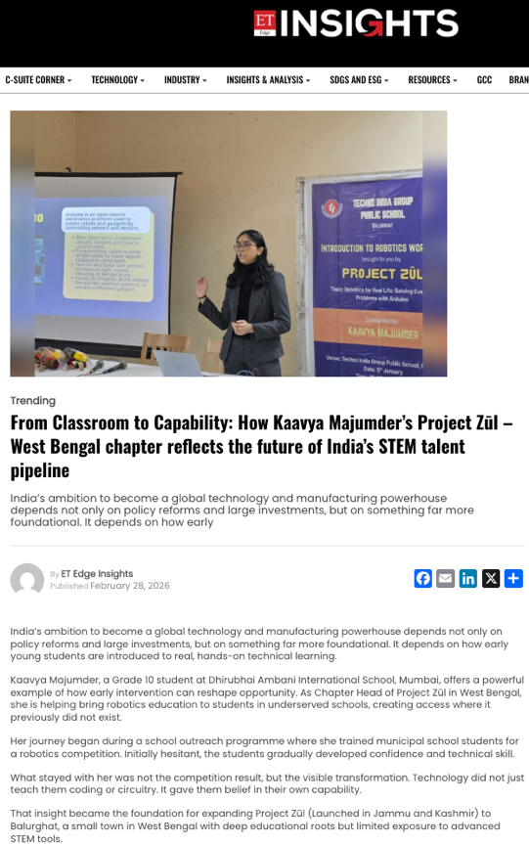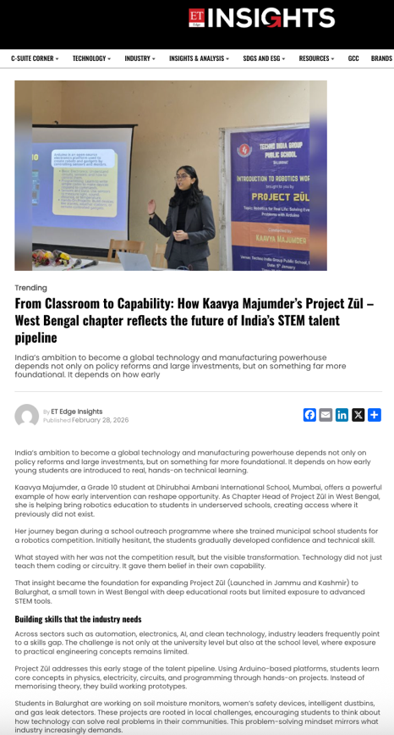

2) Publication name: Anandabazar Patrika
Publication Logo
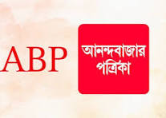
Short Title: A high school student from Mumbai conducted a robotics workshop encouraging students to apply scientific knowledge to solve environmental problems around them
Link
No link as this is a printed media
Screenshots (you can edit to be shorter to fit)
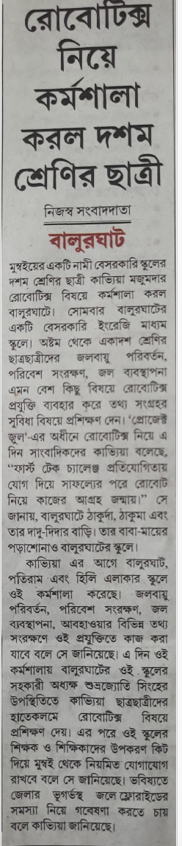

3) Publication Name: Ei Samay Patrika
Publication Logo

Short Title: Robotics Workshop by Mumbai Teen on Applying STEM to Solve Real-World Problems
Link
No link as this is a printed media
Screenshot
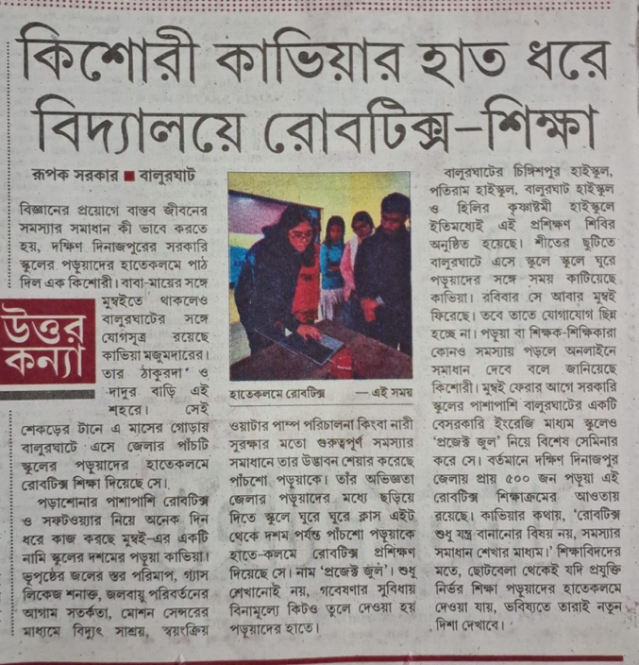

4) Publication Name : Millenium Post
Publication Logo

Short Title: Roots Pride: Mumbai girl brings robotics workshops to Balurghat
Link
https://www.millenniumpost.in/bengal/roots-pride-mumbai-girl-brings-robotics-workshop-to-balurghat-642752
Screenshot
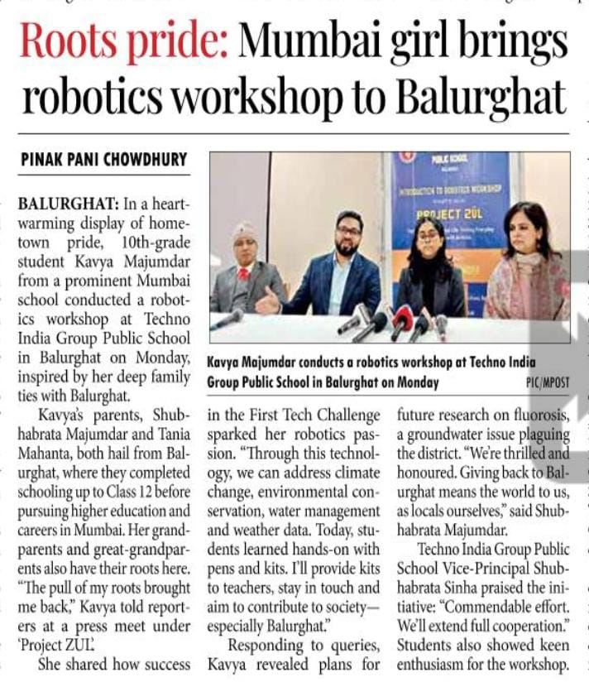

5) Publication Name: TV 9 Bangla
Publication Logo

Link
https://tv9bangla.com/west-bengal/dakshin-dinajpur/kavya-girl-from-balurghat-giving-training-to-school-students-on-robotics-1272434.html
Short Title: Kaavya Majumder, a young student has begun introducing robotics workshops in local schools, where students have shown strong interest in the device she developed.
Screenshots (you can edit to be shorter to fit)

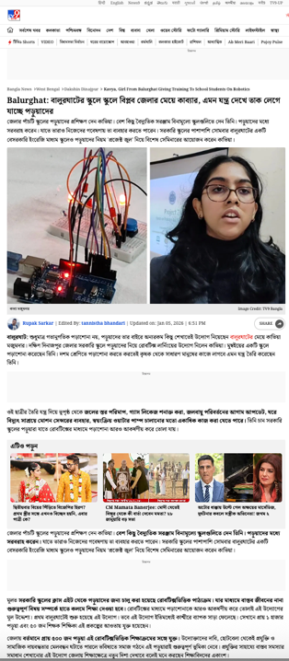

6. Publication Name: DD Local
Publication Logo

Link
https://www.facebook.com/reel/956031597589899
Short Title: Back to Her Roots: Mumbai teen returns to Balurghat to share Robotics knowledge with local students
Screenshot
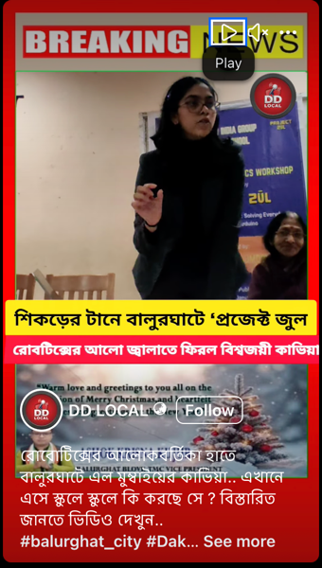

7) Publication Name: Hilli News
Publication Logo


Link
https://www.facebook.com/reel/729789979806459

Short Title: A Robotics Workshop Focused on Environment and Society: An Innovative Initiative by Kaavya Majumder in Balurghat
Screenshot
